**Zabbix Quickstart User Guide**

**Login & configuring User**

<https://www.zabbix.com/documentation/7.0/en/manual/quickstart/login>

Go to http://<nginx_server_ip>/zabbix

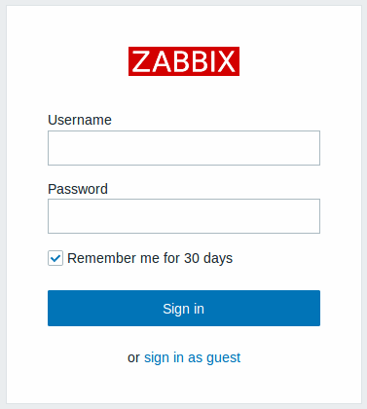

Enter the username **Admin** with password **zabbix** to log in as a [Zabbix superuser](https://www.zabbix.com/documentation/7.0/en/manual/config/users_and_usergroups/permissions). Change the default password for the Admin account.

**Persistent login**

To stay logged in for up to 30 days, select *Remember for 30 days* before clicking *Sign in*.

Remember for 30 days enabled:

* Your session remains active for 30 days.
* [*Auto-logout*](https://www.zabbix.com/documentation/7.0/en/manual/web_interface/user_profile#user-profile) is overridden, keeping you signed in until the period ends.
* You will be auto‑logged in on future visits within 30 days without re‑entering credentials.

Remember for 30 days disabled:

* Any previously enabled auto-login is cleared.
* Session will expire according to the configured *Auto‑logout* interval.

**Protection against brute force attacks**

In case of five consecutive failed login attempts, Zabbix interface will pause for 30 seconds to prevent brute force and dictionary attacks. The IP address of a failed login attempt will be displayed after a successful login.

**Adding user**

To view information about users, go to *Users → Users*.



To add a new user, click on *Create user*. In the new user form, make sure to add your user to one of the existing [user groups](https://www.zabbix.com/documentation/7.0/en/manual/config/users_and_usergroups/usergroup), for example 'Zabbix administrators'.

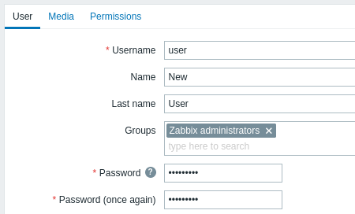

By default, new users have no media (notification delivery methods) defined for them. To create one, go to the 'Media' tab and click on *Add*.

